

**Test 1 Vectors, Projectile, Circular, Gravitational & Satellite motion  
PHYSICS 3AB TASK 3**

**Kingsway Christian College**

**March 6, 2015**

Instructions:   
Answer **ALL** questions.  
You may use your formula book and scientific calculator.  
Give all numerical answers correct to 3 significant figures.  
You are required to show **ALL** working in order to be given appropriate marks.   
A correct answer with no working could receive only ${\frac{1}{5}}^{th}$ of the marks allotted.   
It is a good idea to draw free body diagrams for questions involving forces.

It is also good to use clear, neat diagrams when appropriate.

**Marks________/85 = _______%**

**Section A: Short answer questions 35 out of 85 marks.**

1. A person $P$ walks at a speed of 1.50 m.s−1 on a moving travellator $T$ in an airport terminal. The travellator moves at 0.800 m.s−1. How fast is the person moving with respect to the Earth? [2]

**1.5 m.s−1**

**0.5 m.s−1**

**2.3 m.s−1**

+ =   
**2.30 m.s−1 relative to Earth. **

1. A river flows due east at 5.00 km.h−1. A motorboat can move through water at 12.0 km.h−1.
   1. If the boat heads due north across the river, what will be the direction and magnitude of its velocity. [2] $V_{Resultant}=\sqrt{{12}^{2}+5^{2}}=13.0 km.h^{-1}$ $= \tan^{-1}\left(\frac{5}{12}\right)=22.6^{o}$
         
        **∴ direction is N 22.6 o  E or True bearing 023o or 22.6o   
       Magnitude of velocity = 13.0 km.h−1 or 3.61 m.s−1 **

***θ***

* 1. In what direction should the boat head if it is to travel due north across the river? [2] $= \sin^{-1}\left(\frac{5}{12}\right)=24.6^{o}$ 
       
       **  
      ∴ boat must head N 24.6 o W or True bearing 335o or 335.4o **

***θ***

* 1. If the river is 250 m wide, how long will the crossing described in part b) take? [2]  
     **In part b) $V_{Resultant}=\sqrt{{12}^{2}- 5^{2}}=10.91 km.h^{-1}= \frac{10.91}{3.6}=3.03 m.s^{-1}$   
     Displacement in the direction of ${ V}_{Resultant}$ is 250 m  
     ∴ time taken is calculated $Time= \frac{displacement}{velocity in the direction of displacement}=\frac{250}{3.03}=82.5 s$

**

1. A pilot of a Qantas jet flies from Perth to Sydney. Assume Sydney is due east of Perth. During the flight there was a constant 120 km.h−1 blowing from the northeast. The jet had an airspeed of 1000 km.h−1. The fight time was 4.50 hours. What is the displacement of Sydney from Perth? [3]  
     
     
     
     
     
      
     
     
     
   **First find *θ using the sine rule: *** 

***θ***

***45o***

***135o***

***N***

***Perth***

***Sydney***

***Vw 120 km.h−1***

***VP 1000 km.h−1***

***VResultant  1km.h−1***

1. Below are two sketches of paths of an object in projectile motion. One motion is without air resistance and the other is with air resistance. The initial projectile velocity is shown as $\vec{u}$
   1. Indicate which the one with air resistance is. **Dotted curve ** [1]
   2. At the positions marked A, B & F draw arrows to indicate the appropriate vectors showing, the vertical, horizontal and resultant velocities.   [3]
   3. At the positions marked C, D & E draw arrows to indicate the appropriate vectors showing the resultant acceleration.  [3]  
        
      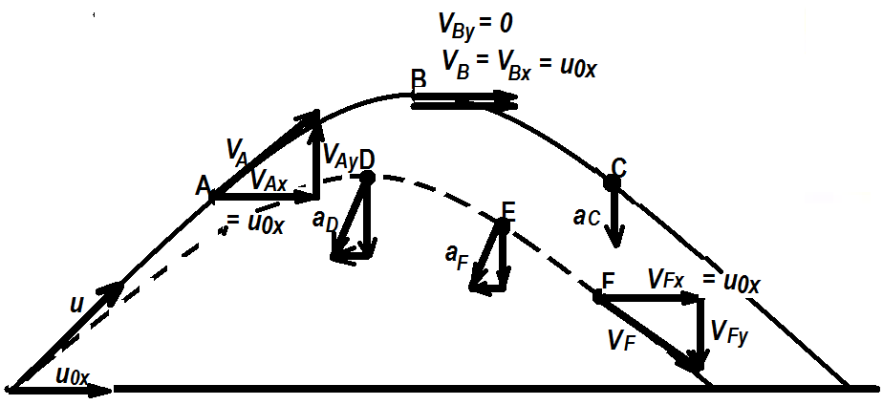
2. Suppose a car moves at constant speed along a hilly road. By choosing from the following four alternatives and explaining with diagrams and equations:  
     
   (a) at the top of the hill,   
   (b) on a horizontal level stretch near the top of a hill,  
   (c) on a horizontal level stretch near the bottom of a hill,  
   (d) at the dip between two hills,  
     
   Where does the car exert:  
   1. the greatest force on the road: [2]  
        
        
      **At the dip between two hill  
        
      Here Fc = N − mg = mv2/R  
        
      ∴ N = mg + mv2/R   
        
      (N is the biggest as it has mv2/R added to mg)**  
        
        
      

**W=mg**

**N**

* 1. the least force on the road: [2]  
       
       
     **At the top of the hill  
       
     Here Fc = mg − N = mv2/R  
       
     ∴ N = mg − mv2/R   
       
     (N is the smallest as it has mv2/R subtracted from mg)**  
       
       
     

**W=mg**

**N**

* 1. the same force on the road [2]  
       
       
     **On a horizontal level stretch near the top of the hill and on a horizontal level stretch near the bottom of the hill.  
     Here Fc = 0 since R is ∞ ∴ N = mg for each case of level horizontal straight travel.** 

**W=mg**

**N**

1. How many “accelerators” do you have in a car? There are at least three controls in the car which can be used to cause the car to accelerate. What are they? What acceleration do they produce? [6]  
     
     
   **a) Accelerator for positive forward acceleration (linear)   
   b) Brake for negative forward acceleration (linear)   
   c) Steering wheel for acceleration towards centre of circle. (centripetal) **
2. Between the Earth and the Moon:  
   1. 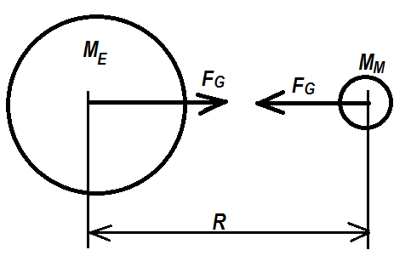 Which pulls harder gravitationally, the Earth on the Moon or the Moon on the Earth? Explain briefly. [1]  
        
      **Each is pulling with the same force : $F_{G}=\frac{GM_{E}M_{M}}{R^{2}}$

**
   2. Which accelerates more? Explain briefly. [1]  
        
      **The moon accelerates more since $a=\frac{F}{m}$; and the moon has the smaller mass and F is the same. **
   3. If the Earth’s mass were double what it is, in what ways would the Moon’s orbit be different? Briefly explain? [3]  
        
      **If the earth’s mass was doubled or increased, the gravitational pull on the moon will increase drawing the moon closer to earth. This will make the rotational speed faster to keep the moon in orbit. This will mean a smaller period. $$F_{G}=\frac{GMm}{R^{2}}=\frac{mv^{2}}{R} GM=Rv^{2}$$ 
      As M increased, GM increased. But R decreased so v2 and hence v will increase and T = 2πR/v will decrease. **

**Section B: Calculations 50 out of 85 marks**

1. A stunt driver wants to make his car jump over eight cars parked side by side below a horizontal ramp.

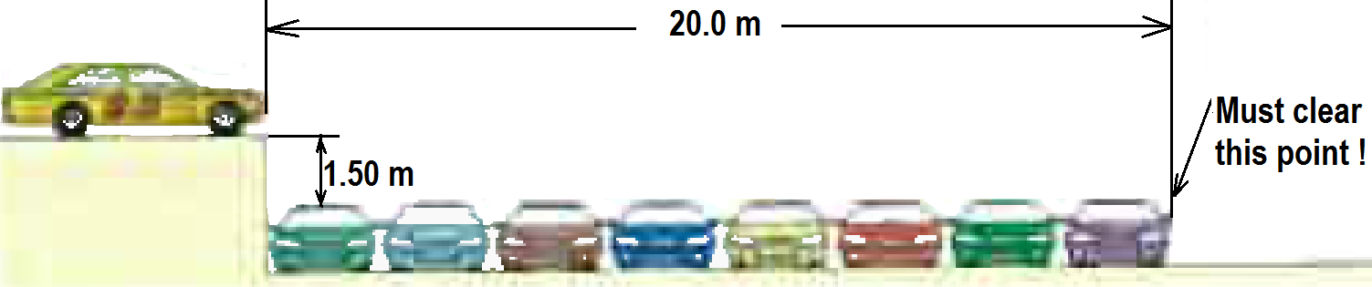

**x**

**y**

**w**

* 1. With what minimum speed must he drive off the horizontal ramp? The vertical height of the ramp is 1.50 m above the cars, and the horizontal distance he must clear is 20.0 m. [4]  
       
     **x motion y-motion  
     s = w t u = 0; a = −9.8 m.s−2  
     20 = wt ∴ v = −9.8t  
      s = − 4.9t2  
       at landing s = −1.5   
      ∴ −1.5 = −4.9t2 **
  2. If the ramp is now tilted upward, so that “take-off angle” is 10.0o above the vertical, what is the new minimum speed? [5]  
       
      **x- motion: y-motion  
      u = wcos10 u = wsin10, a = − 9.8 m.s−2  
      s = w cos10 t v = wsin10 − 9.8t  
      20 = wcos10 t s = wsin10 t − 4.9 t2  
      substitute t = 20/wcos10 and s = −1.5 at landing   
        
        
      **

**x**

**y**

**w**

**10 o**

1. A 0.450 kg ball attached to the end of a horizontal cord, is rotated in a circle of radius 1.30 m on a frictionless horizontal surface. If the cord will break when the tension in it exceeds 75.0 N, what is the maximum speed the ball call have in m.s−1 and also in rotations per minute (rpm) [4]

**Fc = T = 75 = mv2/R  
  
  
if rpm speed is x  
then $v=\frac{x 2 R}{60}; x= \frac{60v}{2R}=\frac{6014.7}{21.3}=108 rpm$

**

**W = mg   
= 0.45 × 9.8 = 4.41 N**

**R = 1.3 m**

A 40.0 kg girl is playing on a maypole swing in a playground. The 2.50 m long rope is attached to a 0.500 m radius horizontal bar at the top, and makes an angle of 75.0o to the horizontal as she swings freely in a circular path. Ignore the mass of the rope in your calculations.

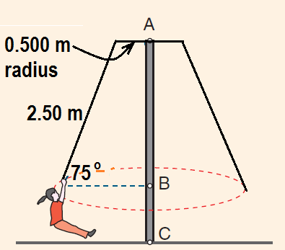

**T **

**W = mg **

* 1. Calculate the radius of her circular path. [1]  
       
     **r = 0.5 + 2.5cos75 = 1.15 m **
  2. Indicate on the diagram, the forces acting on the girl as she swings. [2]
  3. What is the net force and net acceleration on the girl in the position shown? [3]
  4. Calculate the rotational speed and tension in the rope. [5]  
       
     **Tsin75 = mg = 40 × 9.8 = 392; ∴ T = 392÷ sin75 = 406 N   
     Net force, Fnet is Tcos 75 = 406 cos75 = 105 N and is directed towards centre B  ½   
     The net acceleration is Fnet/m = 105/40 = 2.63 m.s−2 directed towards the centre B  ½   
     Using ac = v2/R; ∴ v = √(R×ac) = √(1.15× 2.63) = 1.74 m.s−1   
     or (60 × 1.74)/(2π × 1.15) = 14.4 rpm**

1. A ball on the end of a string is revolved at a uniform rate in a vertical circle of radius 72.0 cm as shown. If its speed is 4.00 m.s−1 and its mass is 0.300 kg, calculate the tension in the string when the ball is

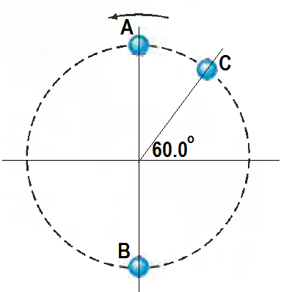

**W = mg   
= 2.94 N**

**W = mg   
= 2.94 N**

**W = mg   
= 2.94 N**

**TC**

**TB**

**30o**

**TA**

* 1. At the top of its path $A$. [3]  
       
     **At A  
     Fc = Net force towards the centre  
     = TA + 2.94 = mv2/R   
     ∴ TA + 2.94 = 0.3 × 42/0.72 =6.67  
     ∴ TA = 6.67 − 2.94 = 3.73 N towards the centre of circle **  
     (No direction − ½ )
  2. At the bottom of its path $B$. [3]  
       
       
     **At B  
     Fc = Net force towards the centre  
     = TB − 2.94 = mv2/R   
     ∴ TB − 2.94 = 0.3 × 42/0.72 =6.67  
     ∴ TB = 6.67 + 2.94 = 9.61 N towards the centre of circle **  
     (No direction − ½ )
  3. At 60.0o from the horizontal upwards as it moves upwards $C$. [3]  
       
       
     **At C  
     Fc = Net force towards the centre  
     = TC + 2.94cos30 = mv2/R   
     ∴ TC + 2.94cos30 = 0.3 × 42/0.72 =6.67  
     ∴ TC = 6.67 − 2.94cos30 = 4.12 N towards the centre of circle **  
     (No direction − ½ )

1. Calculate the acceleration due to gravity on the surface of the moon. [3] $g=\frac{GM}{r^{2}}= \frac{6.67 {10}^{-11} 7.35 {10}^{22}}{{\left(1.74 10^{6}\right)}^{2}}=1.62 m.s^{-2}$ 
     
     
    **towards centre of moon **  
     
   1. During an Apollo lunar landing mission, the command module continued to orbit the Moon at an altitude of 100 km. What is the gravitational field strength at this altitude? [2] $g=\frac{GM}{R^{2}}=\frac{6.67 {10}^{-11} 7.35 {10}^{22}}{{\left(1.74 10^{6}+100000\right)}^{2}}=1.45 N.{kg}^{-1}$ 
        
        
        
        
       **Towards the centre of the moon. **

**100000 m**

**Rm = 1.74 × 106 m**

**R = 1.74 × 106 + 100000 m**

* 1. How long did it take to orbit the Moon at this altitude? [3]  
       
       
     **At this location ac = g = 1.45 = v2/R  
     ∴ v = √(R × 1.45) = √[( 1.74 × 106 + 100000) × 1.45] = 1632.29 m.s−1  
     since 2πR/T = v; ∴ T = 2πR/v = [2π × (1.74 × 106 + 100000)]÷ 1632.26 = 7082.7 s  
     ≈ 7080 s or 118 mins or 1hr 58 mins 2.7 s **

1. A toy device is made up of a 200 g ball attached by two cables to a spinning shaft as shown. Calculate the tension in each cable when the shaft spins at 360 rpm. [5]  
     
   **R = 0.5sin60 = 0.433 m  
   v = 360 × 2πR/60 = (360 × 2π × 0.433)/60 = 16.32 m.s−1**  
     
     
   **For vertical force balance  
   T1cos 60 = T2cos60 + 1.96 ...i   
   Fc = T1sin60 + T2sin60 = mv2/R  
   = 0.2 × 16.322/0.433 = 123.08 …ii   
   from …i  
   T1 = T2 + 3.92 …iii  
   from ..ii  
   T1 + T2 = 142.12 …iv  
   ∴ T2 + 3.92 + T2 = 142.12  
   2T2 = 142.12 − 3.92 = 138.2  
   ∴ T2 = 138.2 ÷ 2 = 69.1 N   
   T1 = T2 + 3.92 = 69.1 + 3.92 = 73.0 N **

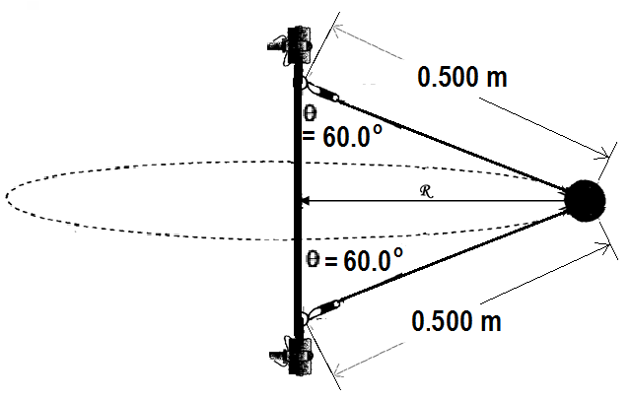

**T1**

**T2**

**T1cos60**

**T1sin60**

**T2cos60**

**T2sin60**

**W = mg   
= 0.2 × 9.8   
= 1.96 N**

1. A boy throws a dart at a certain angle upwards from the horizontal, 2.00 m from the dartboard. The dart hit the dartboard at the same height above ground that it was thrown. It was observed that it achieved a maximum height of 19.6 cm above the release point. Calculate the angle and the release velocity of the dart. [4]  
   **y-motion from maximum height where u = 0, a = −9.8,   
   s = − 0.196. Use v2 = u2 + 2as to get   
   v =   
   from s = ut + ½ at2;   
   ∴ total travel time = 2 × 0.2 = 0.4 s   
     
   x motion: constant with s = 2 and t = 0.4 , u = v = 2 ÷ 0.4 = 5.00 m.s−1**  
     
     
     
    ** **

***θ***

**Uy = 1.96 m.s−1**

**Ux = 5.00 m.s−1**

**w**

***θ***

**w**

**y**

**x**

**2 m**

**0.196 m**

**END OF TASK 3 (Test 1)**